
REPORT
OF
WEB DEVELOPMENT INTERNSHIP

Submitted To
School of Computer Science and Engineering
IILM University, Greater Noida, U.P.
In partial fulfilment of the requirement for the degree of
B.Tech CSE
By
Name of Student: ANAND RAJ
Roll No. of Student: 25SCS1003005435
Batch: 2025 – 2029
Academic Year: 2026 – 2027
Prodigy InfoTech

1. CANDIDATE’S DECLARATION
I, ANAND RAJ, do hereby declare that the internship report titled “WEB DEVELOPMENT INTERNSHIP” has been prepared by me to fulfil the requirement for the award of the degree of Bachelor of Technology in Computer Science and Engineering. The work presented in this report is based on my learning and practical work carried out during the Web Development Internship at Prodigy InfoTech. I affirm that the report has not been submitted to any other institute for any degree or diploma requirement.
Signature: __________________________
Student Name: ANAND RAJ
Roll No.: 25SCS1003005435

2. ACKNOWLEDGEMENT
I would like to express my sincere gratitude to everyone who supported and guided me throughout my Web Development Internship at Prodigy InfoTech. The internship provided me with an opportunity to gain practical exposure to web application development and to apply programming concepts while working on assigned technical tasks.
I am thankful to IILM University, the faculty members, and Prodigy InfoTech for providing this learning opportunity. I am also grateful to my parents and well-wishers for their continuous support and encouragement.
The practical work helped me improve my understanding of web application development, database connectivity, authentication, validation, debugging, and project organization. It also strengthened my problem-solving skills and confidence in developing and testing web-based applications.
Signature: _________________________
Student Name: ANAND RAJ
Roll No.: 25SCS1003005435

3. INTERNSHIP COMPLETION CERTIFICATE
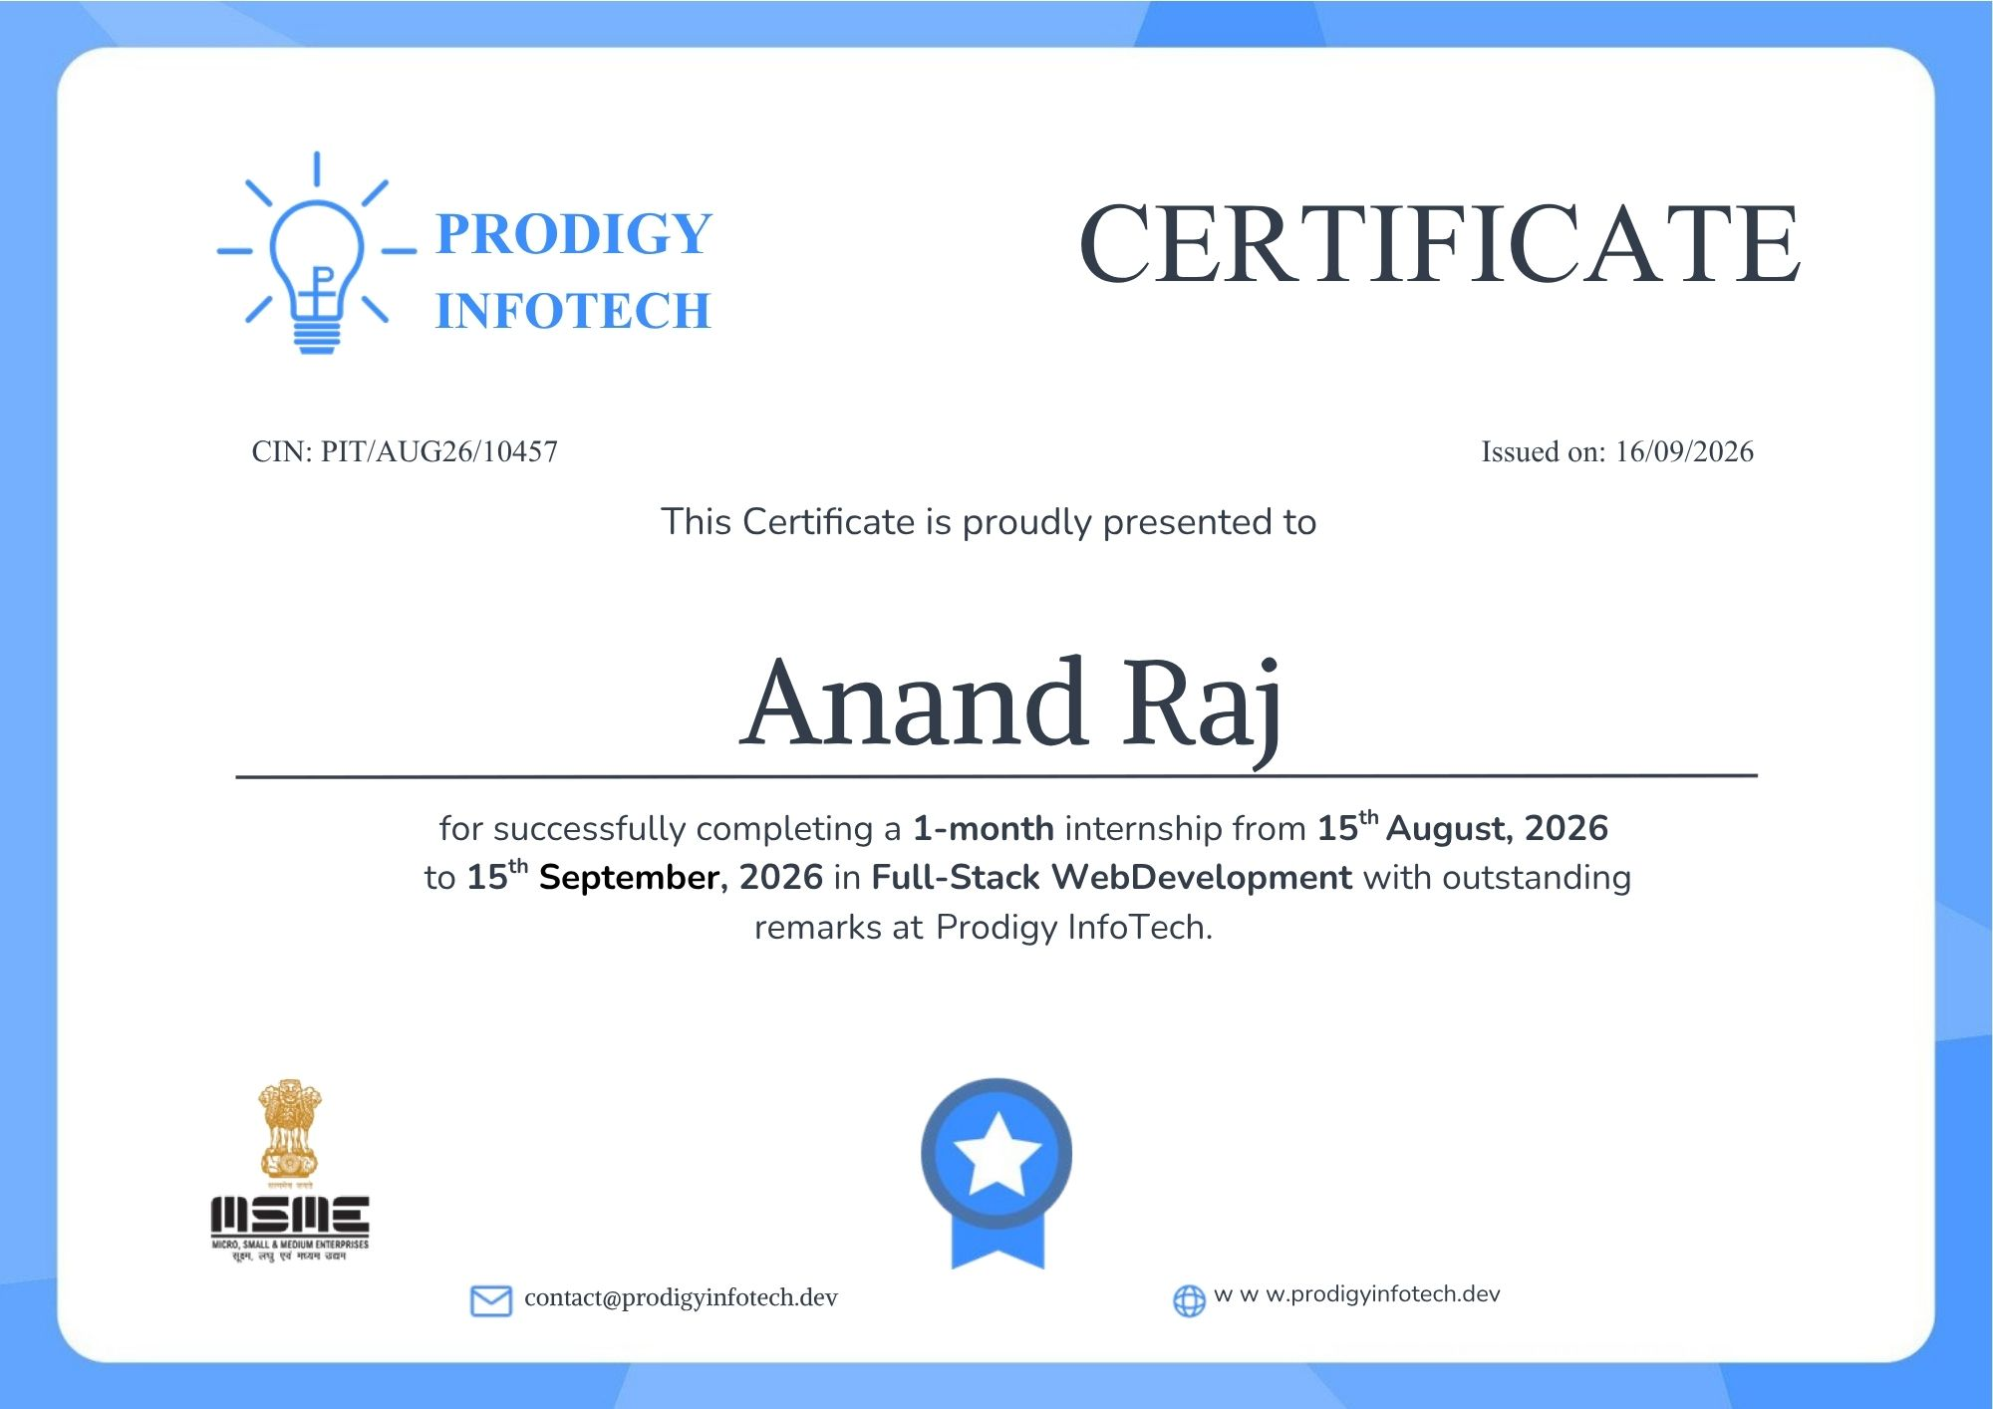

4. PROJECT DESCRIPTION

4.1 INTRODUCTION
The Web Development Internship at Prodigy InfoTech provided practical exposure to the development of web-based applications. The assigned work covered frontend interfaces, server-side programming, authentication, validation, database operations, and secure handling of user or employee information.
The documented internship task track includes Secure User Authentication, Employee Management System, Local Store E-commerce Platform, Real-Time Chat Application, and Social Media Platform. The first task was implemented and tested during the internship work, while the remaining task outputs in this report are generated UI demonstrations based on the supplied task requirements.

4.2 ORGANIZATION PROFILE
Prodigy InfoTech provided the opportunity for this Web Development Internship as part of its practical learning and project-based internship program. The internship focuses on giving learners hands-on exposure to software and web development through assigned technical tasks.

4.3 PROBLEM STATEMENT
Modern web applications require secure authentication, reliable data handling, proper validation, and controlled access to sensitive information. The internship tasks were designed to provide practical experience in implementing these requirements while maintaining functional and user-friendly interfaces.

4.4 PROJECT OBJECTIVES
- To gain practical experience in web application development.
- To strengthen knowledge of frontend and backend technologies.
- To implement secure user registration and login functionality.
- To understand password hashing and token-based authentication.
- To work with MongoDB for persistent application data.
- To understand CRUD operations for employee records.
- To build responsive and user-friendly web interfaces.
- To understand real-time communication and social interaction concepts.
- To improve debugging, testing, and problem-solving skills.

4.5 SCOPE OF THE PROJECT
The scope of the internship work covers full-stack web application development. The tasks demonstrate authentication and protected routes, employee record management, e-commerce interfaces, real-time communication, and social media functionality. These projects provide a foundation for future development and can be extended with additional backend services, database operations, deployment, and security controls.

4.6 TECHNOLOGIES AND TOOLS USED
- HTML5 – structure of web interfaces, forms, navigation and content.
- CSS3 – layouts, responsive design, styling, cards, buttons and visual presentation.
- JavaScript – client-side interaction and application logic.
- Node.js – server-side JavaScript runtime.
- Express.js – backend server and API routes.
- MongoDB / Mongoose – persistent data storage and database operations.
- bcrypt – password hashing for secure credential storage.
- JWT – token-based authentication and protected route access.
- Visual Studio Code – development environment and code editor.
- Git / GitHub – version control and project submission.

4.7 SYSTEM ARCHITECTURE
The implemented authentication application follows a client-server architecture. The browser provides the user interface and sends requests to a Node.js/Express backend. The backend validates input, communicates with MongoDB, hashes passwords using bcrypt, and generates authentication tokens. Protected routes verify the token before returning protected information.

4.8 METHODOLOGY
- Understanding the task requirements.
- Planning the structure and user interface.
- Developing frontend components using HTML, CSS and JavaScript.
- Implementing backend routes and application logic where required.
- Connecting the application with a database for persistent data.
- Applying validation and security mechanisms.
- Testing the application in a browser and correcting issues.
- Preparing screenshots and documentation for final submission.

5. TASKS ASSIGNED
The internship task track documented in this report consists of the following five tasks:
Task | Project
Task 1 | Secure User Authentication
Task 2 | Employee Management System
Task 3 | Local Store E-commerce Platform
Task 4 | Real-Time Chat Application
Task 5 | Social Media Platform
The following pages contain output screenshots for each task. They are included as visual of the intended web application outputs based on the supplied task descriptions.

Task 1 – Secure User Authentication
Task Objective: Implement a user authentication system with secure login and registration functionality. Users should be able to sign up, log in securely, and access protected routes only after successful authentication.
Output Screenshot
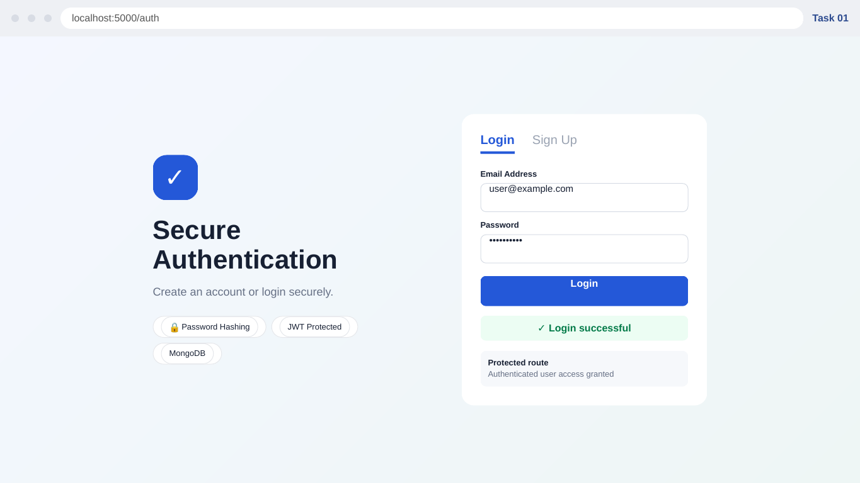
Figure 1:working-interface output for Task 1 – Secure User Authentication.
Key features demonstrated:
- Login and registration interface
- Password hashing and secure credential handling
- JWT-based authentication
- Protected route access
- MongoDB-backed user records

Task 2 – Employee Management System
Task Objective: Develop a web application that allows administrators to perform CRUD operations on employee records with proper validation and authentication mechanisms.
Output Screenshot
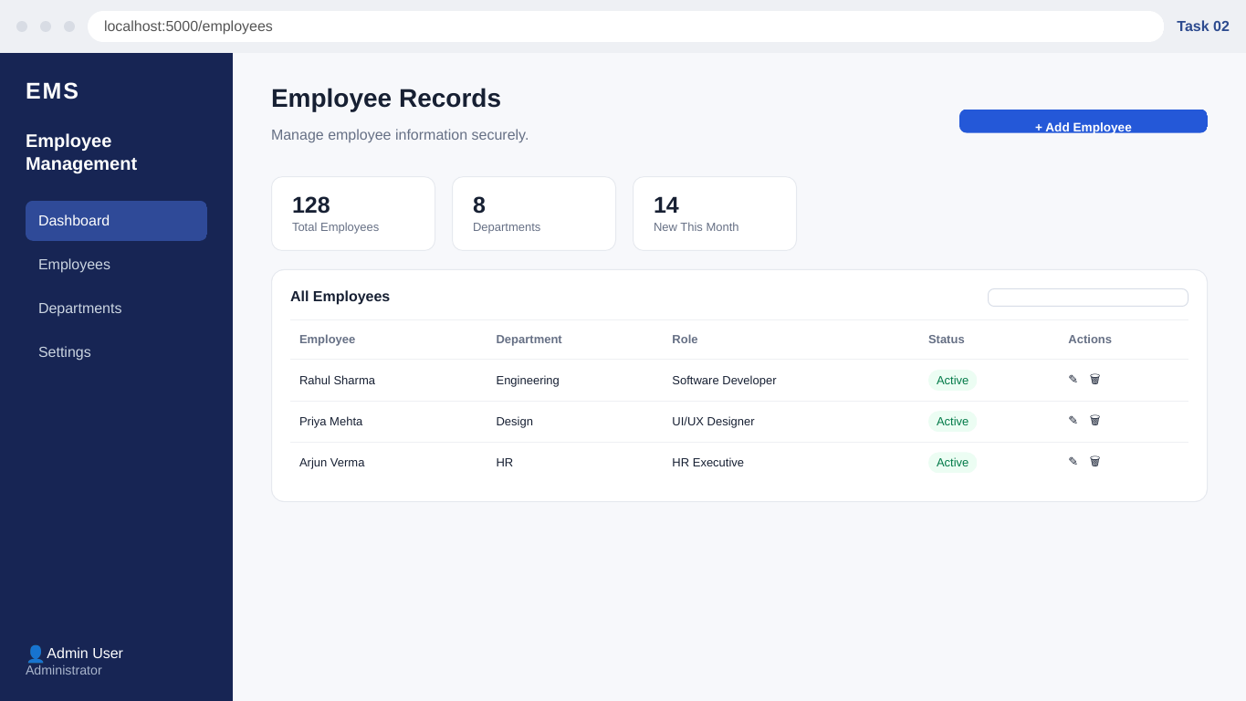
Figure 2: working-interface output for Task 2 – Employee Management System.
Key features demonstrated:
- Employee dashboard
- Add, read, update and delete controls
- Department and role information
- Searchable employee records
- Authenticated administrative interface

Task 3 – Local Store E-commerce Platform
Task Objective: Develop a local e-commerce web application that enables customers to browse products and purchase products online through a practical shopping interface.
Output Screenshot
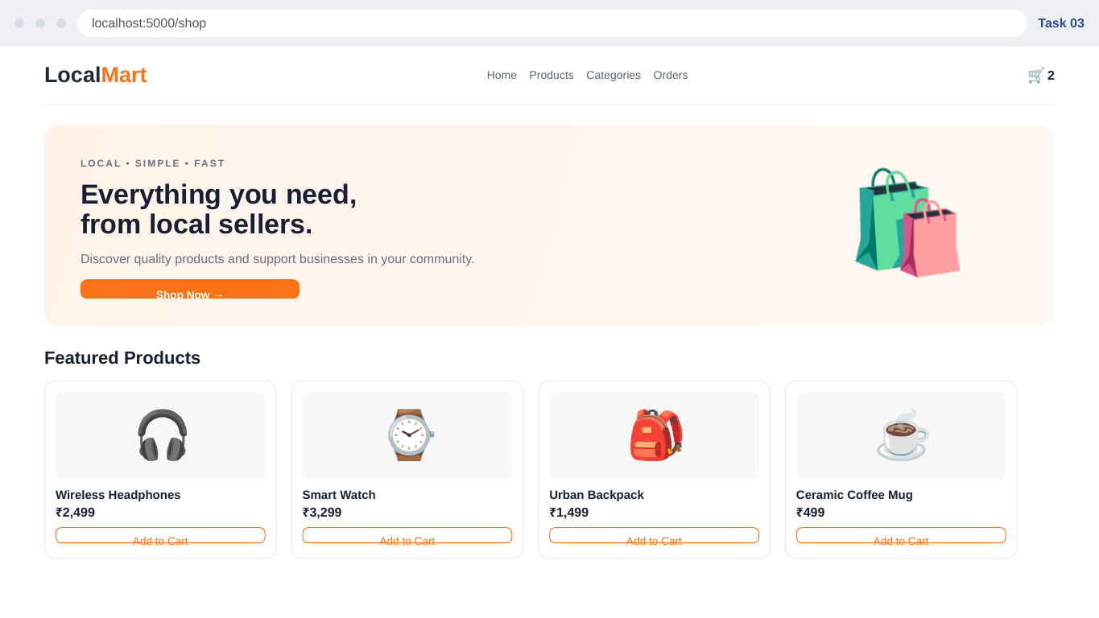
Figure 3: working-interface output for Task 3 – Local Store E-commerce Platform.
Key features demonstrated:
- Product catalogue
- Product cards and prices
- Shopping cart indicator
- Category/navigation interface
- Add-to-cart interaction

Task 4 – Real-Time Chat Application
Task Objective: Develop a real-time chat application using WebSocket technology to enable instant messaging between users.
Output Screenshot
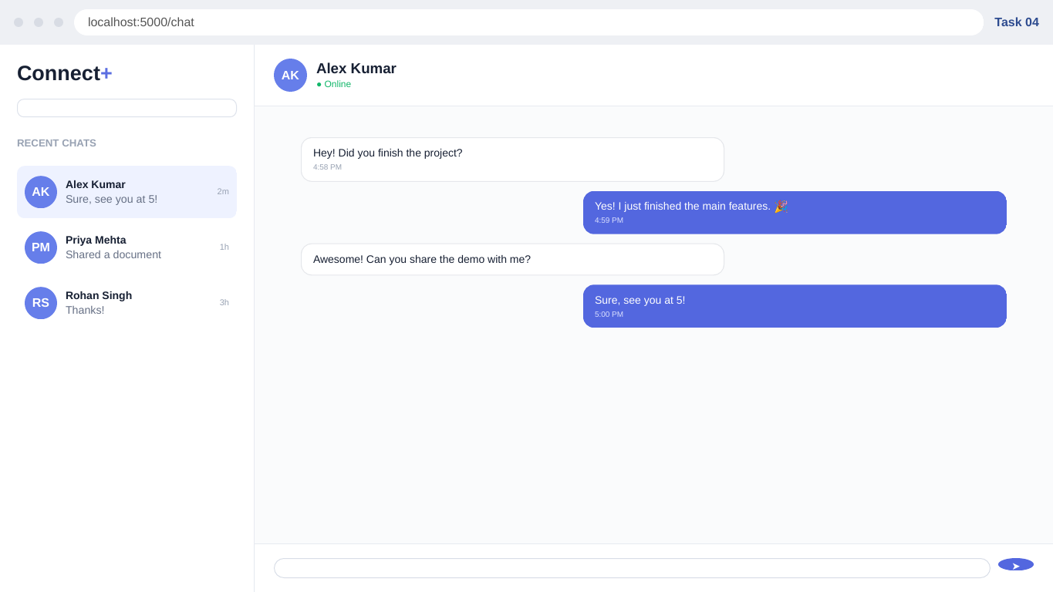
Figure 4:working-interface output for Task 4 – Real-Time Chat Application.
Key features demonstrated:
- Conversation list
- Online status
- Message history
- Sender and receiver message styling
- Message composer

Task 5 – Social Media Platform
Task Objective: Build a social media application where users can create profiles, share posts and interact with other users.
Output Screenshot
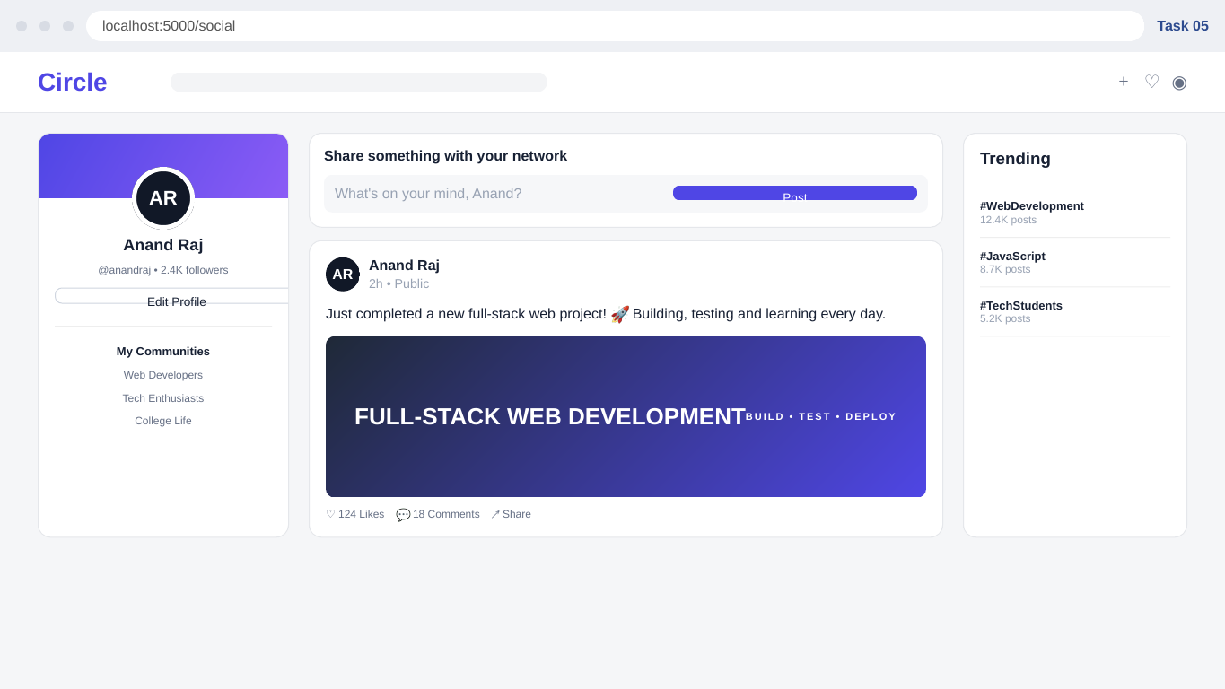
Figure 5: working-interface output for Task 5 – Social Media Platform.
Key features demonstrated:
- User profile
- Post composer
- Feed-style post
- Likes/comments/share controls
- Trending topics

6. RESULTS AND OUTCOMES
The internship tasks provided practical exposure to the process of translating software requirements into user-facing web application interfaces. The Secure User Authentication project provided hands-on experience with frontend forms, server-side APIs, password hashing, MongoDB storage, token-based authentication and protected route testing. The remaining task demonstrations show how the same web development foundation can be extended to employee management, e-commerce, real-time communication and social media applications.

6.1 LEARNING OUTCOMES
- Improved understanding of full-stack web application structure.
- Practical experience with HTML, CSS and JavaScript.
- Better understanding of Node.js and Express.js.
- Understanding of secure password storage using hashing.
- Understanding of token-based authentication and protected routes.
- Practical experience connecting an application to MongoDB.
- Improved debugging and browser-based testing skills.
- Improved ability to read and implement technical task requirements.
- Experience documenting development work using screenshots and structured reports.

6.2 FUTURE ENHANCEMENTS
- Deploy applications to a cloud hosting environment.
- Add stronger validation, rate limiting and security headers.
- Implement role-based access control for administrative features.
- Add complete backend services and database operations to the remaining task demonstrations.
- Integrate payment and order processing for the e-commerce application.
- Use WebSocket infrastructure for production-grade real-time chat.
- Add moderation, notifications and privacy controls to the social platform.

GitHub Repo

My Repo Link:- https://github.com/LuffyJod/Prodigy-Infotech-Internship.git

7. CERTIFICATE / SUPPORTING DOCUMENTS
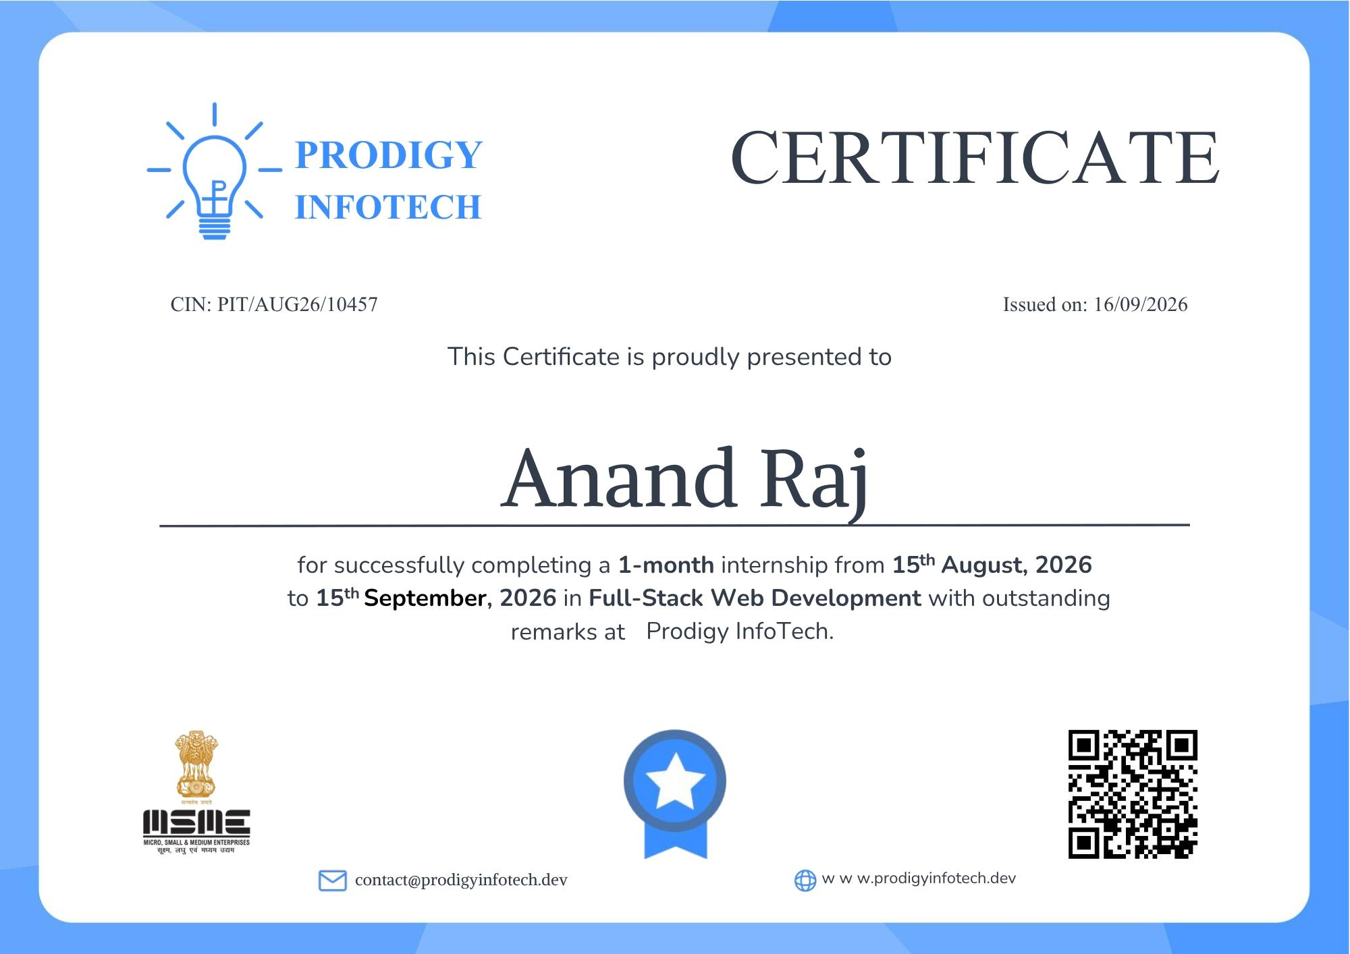

SUPPORTING DOCUMENTS/OFFER LETTER

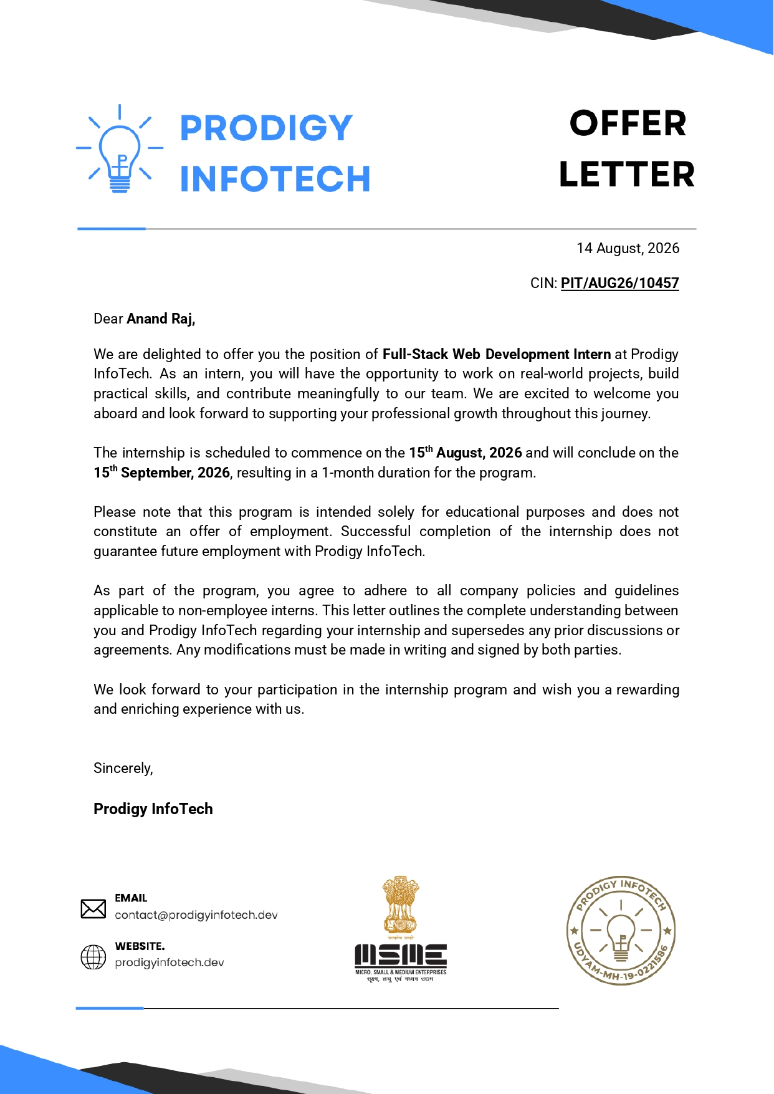

8. BIBLIOGRAPHY / REFERENCES
1. Prodigy InfoTech, Internship Offer Letter and Internship Task Materials, 2026.
2. MDN Web Docs, HTML, CSS, JavaScript and Web API documentation.
3. Node.js Documentation.
4. Express.js Documentation.
5. MongoDB Documentation.
6. Mongoose Documentation.
7. bcrypt package documentation.
8. JSON Web Token (JWT) documentation.

